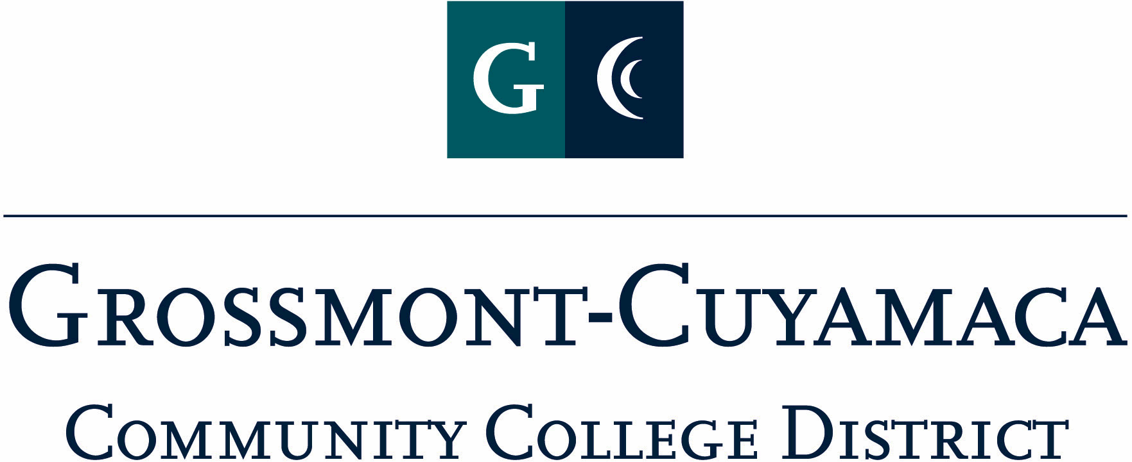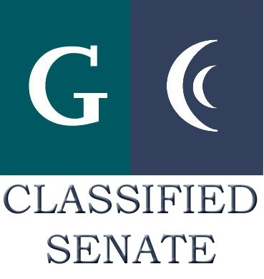
CLASSIFIED SENATE
EXECUTIVE BOARD MEETING
June 1, 2010 – Meeting Minutes

Members Present: Kimberly Gioscia, Maria Briney, Angela Johnson, Wendy Corbin, Yvette Macy, Maggie Gonzales
Members Absent: Tasa Campos, Scott Howell, Jean Wallace
Members Excused: Paula Tillery, Avelina Wilder, Monica Farris, JacQueline Osborne, Karen McCoy, Karen

1. Welcome and Call to Order
The meeting was called to order at 12:10p.

2. Approval of Minutes from April 13, 2010
Quorum was not met, the minutes will be disseminated to the group via e-mail, and a record kept of the approval.

3. Communication
VP Reports
District: The District asked for Classified Senate to name two representatives for the District Planning and Budget Jam (PB&J). At this time Wendy Corbin has put forward two names from the four volunteers and is awaiting final approval from Debi Miller and Jan Recktenwald. Once the final approval is received the volunteers will be communicated to the Senate. Wendy Corbin also indicated that she prepared a form that the members of committees could use to provide monthly updates on the committee’s progress. The form/notes would be used by Wendy Corbin as a part of the District V. P. report, and also passed to CSEA for dissemination to their group as well.

Cuyamaca: Maggie Gonzales reported out that the Cuyamaca College meeting with Chancellor Miles was good, and that the last IPC meeting was to discuss Basic Skills and the Fitness center use by employees.

In response to Maggie’s summary of the leadership meeting with the Chancellor and the ideas for student worker appreciation; Wendy Corbin brought forward the idea of possibly implementing goal setting and evaluations of the student and part time hourly employees. Maggie asked that Wendy check with Chemene in Employment Services to see if there may be any issues that could arise from this process. It was suggested that this tool could be used to acknowledge the accomplishments of this group of employees as well as be a great representation for Classified Senate.

President’s Report: Debi Miller is on vacation.

Treasurer Report: Nothing brought forward

4. Continuing Business
Mother Goose Parade: Wendy Corbin reported that a draft of the proposal for the Mother Goose Parade was ready for review by Debi when she returns. We are also working on the liability insurance component with the Risk Management Office so that we have the proper evidence of coverage. Yvette added she would like to arrange a Mother Goose Parade committee and would like to postpone the suggestion until the next meeting when more people were present. Maggie Gonzales expressed interest in being a part of that committee.

5. Fundraising Activities:
BBQ Fundraiser: Yvette Macy reported Grossmont Financial Aid had a successful BBQ fundraiser raising approximately $1000.00 to go towards scholarships, and suggested Classified Senate put on their own BBQ Fundraiser. Profits can help fund a number of activities, such as, Scholarships, Mother Goose Parade, or an Hourly type award, as suggested by Wendy Corbin regarding hourly goal setting evaluations.

Pat Murray added that she has spoken to Cari Plyley, President Emeritus at 4CS, customarily at the CLI event they highlight the award winners from each of the college. Debi Miller will be highlighted as well for receiving her recent award from 4CS for her help in organizing the Southeast Region Leaders Retreat.

The meeting adjourned at 12:37p.

